Main title of your abstract, two lines if needed
(Main title style: Arial Bold, 14pts, centred)

Presenting author (T. Dupont)¹, Author 2² and Author 3³
(Authors list style: Arial, 11pts, centred)

¹Affiliationpresenting author
²Affiliation second author
(Institutions list style: Arial italic, 9pts, centred)

e-mail: presentingauthor@xx.com
(email style: Arial, 9pts, centred)

Abstract text
(Body text style: Arial, 10pts, text justified)
This document contains the instructions to prepare and submit your abstract for Impulse Days Bioactive and Biofunctional Peptides. The presentation materials are in English, and the oral presentation can be either in French or in English. The abstract should summarize the objectives, methodology, results, and conclusions of the work. Page format: A4 (210 × 297 mm); margins: 20 mm on all sides.

Once finalized, all instructions in colors must be removed, the abstract must be converted to PDF format and uploaded via this link: https://impulsedays.fr/peptides/

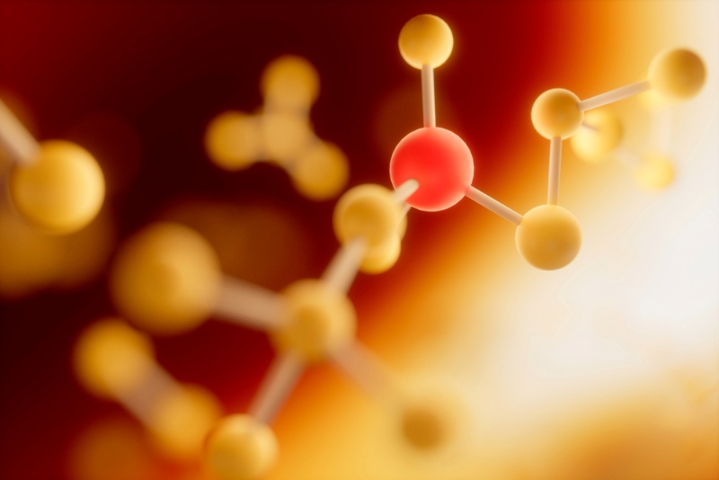

Figure 1: One figure or graph if needed (Arial, centred, 9 pts)

[Keywords]:
At least 3 keywords are required with all letters in lower case and not bold.
[Keywords style]: Arial italic, 10pts, text justified)

References
[1] A. Martin, B. Dupont, C. March, Journal 163 (2006) 192-156.
[2] A. Martin "Title" in Book title (D. Durand, Ed.), Editor, City, 2007, p.10.
(Body text style: Arial, 9pts, text justified)

